**Department of Electronics and Telecommunication Engineering**

**Module wise University Questions**

**(Second Half of 2020)**

**fac**

**Class/Sem: BE/VIII Branch: EXTC**

**Subject: OCN**

**Module 2: Transmission Characteristics of Optical Fiber**

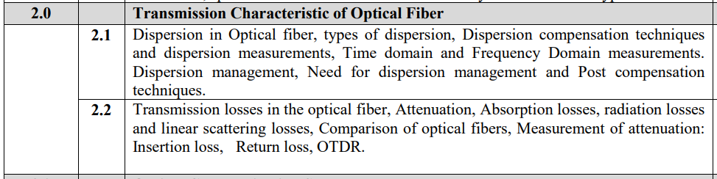

**Dec 2019**

1. Explain linear and non-linear scattering losses in optical fiber. [10m]
2. What are the different factors responsible for attenuation and dispersion in optical fiber. [10m]
3. Draw and explain block diagram of cutback method of attenuation measurement [10]

**May 2019**

1. Compare Linear and Nonlinear Scattering [5m]
2. Explain in brief intermodal and intramodal dispersion in fiber [10m]
3. A 6 km optical link consist of multimode step index fiber with a core refractive index of 1.5 and relative refractive index difference of 1 %. Estimate (i) Delay difference between slowest and fastest modes at the fiber output (ii) RMS pulse spreading due to intermodal dispersion on the link (iii) Maximum bit rate that may be obtained without substantial errors on the link assuming only intermodal dispersion (iv) Bandwidth Length product corresonding ti (iii) [10m]
4. Write short note on Dispersion Compensation [5m]

**Dec 2018**

1. Compare Intermodal and Intramodal dispersion [5m]
2. Explain the Linear and Nonlinear Scattering in optical fiber [10m]

**May 2018**

1. Compare between Intermodal and Intramodal dispersion [5m]
2. Explain the signal attenuation in optical fiber and plot the three windows [10m]

**Dec 2017**

1. Explain OTDR working principle in detail. Mention its limitation [10m]
2. Discuss different types of Dispersion in optical fiber [5m]
3. Explain Macro Bending loss [5m]

**May 2017**

1. Compare Intramodal Dispersion and Intermodal Dispersion [5m]
2. Explain OTDR working principle in detail. [10m]
3. Derive an expression for Time Delay in Intermodal Dispersion [5m]
4. Write short note on Dispersion Compensation [5m]

**Dec 2016**

1. Compare Intramodal Dispersion and Intermodal Dispersion [5m]
2. Derive the expression for pulse spreading in intermodal dispersion [10m]
3. Explain Material attenuation in optical communication [6m]
4. What is microbending loss? Explain how to minimize these losses with neat sketch [8m]
5. Short note on Dispersion and OTDR [5m]

**May 2016**

1. Compare between Intermodal and Intramodal dispersion [5m]
2. Explain OTDR with neat sketch [10]
3. What are the sources of microbending loss? How it can be overcome? [5m]
4. What are the sources of micro bending loss? How it can be overcome?[10]
5. Explain the sources of loss at a fiber joint.[10]

**Dec 2015**

1. A multimode GIF exhibits total pulse broadening of 0.1 μs over a distance of 15 km. Estimate (i) the maximum possible bandwidth on the link assuming no ISI (intersymbol interference) (ii) the pulse dispersion per unit length (iii) the bandwidth length product for the fiber [5m]
2. What is macrobending loss. Explain with neat diagram. Explain how to minimize microbending losses [10m]
3. Explain OTDR with neat sketch and mention its advantages and applications [5m]
4. A multimode GIF exhibits total pulse broadening of 0.1us over a distance of 15 km.
5. a. Estimate (i) The maximum possible Bandwidth or the link assuming no ISI. (ii) The pulse dispersion per unit length.
6. b. (iii) The Bandwidth length product.[05]

**May 2015**

1. Explain Signal Attenuation in optical fibers and plot the three windows[10]
2. Explain intermodal and intramodal dispersion in optical fibers. How does dispersion affect the transmission B.W. of optical fibers?[10]
3. Discuss a popular non-destructive technique for attenuation measurement.[10]

**Dec 2014**

1. What are the factors responsible for optical signal attenuation and dispersion during signal propagation through optical fiber?[10]
2. State the difference between the dispersion shifted and dispersion compensated fibers.[05]

**May 2014**

1. What do you understand by intramodal dispersion? Derive the expression for material dispersion.[10]
2. Explain Bandwidth distance product.[05]

**Dec 2013**

1. Discuss in brief single mode step index fiber and multi mode step index fiber.[05]

**May 2013**

1. List the important factors responsible for power loss in optical fiber. Explain each factor briefly.[10]

**Dec 2012**

1. A 15 km optical fiber link uses fiber with a loss of 1.5 dB km−1. The fiber is jointed every kilometer with connectors which give an attenuation of 0.8 dB each. Determine the minimum mean optical power which must be launched into the fiber in order to maintain a mean optical power level of 0.3 μW at the detector.[07]

**May 2012**

1. Scattering losses in optical fiber.[10]
2. List the important factors responsible for power loss in optical fiber. Explain each factor briefly.[10]
3. Name the key parameters for describing the signal transmission in single mode fiber and multimode fiber.[05]
4. Draw and explain the test-set up for measuring the chromatic dispersion[10]

**Dec 2011**

1. An optical signal at a specific wavelength has lost 55% of its power after traversing 3.5 km of fiber. What is attenuation in dB/km in this fiber [03]